NAME_________________________________________________ PERIOD________ DAY_____

**QUICK BREAD HOMEWORK**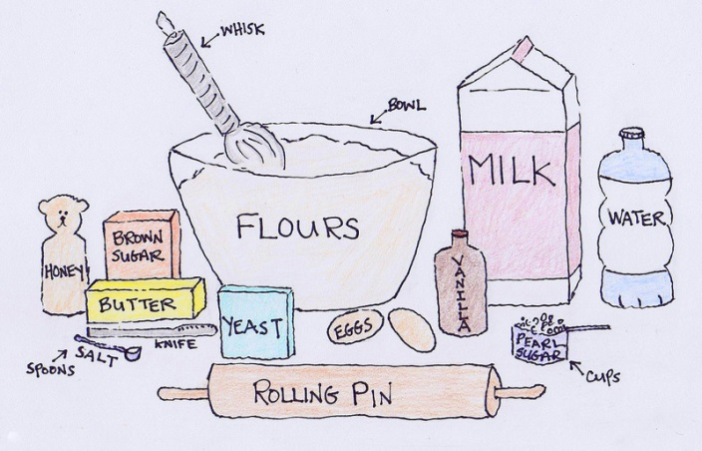

______________1. A leavening agent makes a product or food item rise. What is

one of the leavening agents in a quick bread?

______________2. What is the gas produced in a quick bread?

______________3. What **TYPE** of quick bread can be dropped from a spoon?

______________4. What is an **EXAMPLE** of a pour batter quick bread?

______________5. What ingredient in a quick bread makes all the ingredients

stick together. Hint: It’s a liquid but turns to solid when

heated?

______________6. What ingredient gives a quick bread framework or structure?

______________7. Give one example of a flavoring that might be added to a

quick bread.

______________8. Pancakes are one example of a quick bread. List 3 more

examples of quick breads. (8-10)

______________9.

_____________10.